PRACTICAL-7

Performs CKY Parsing (Cocke–Kasami–Younger Algorithm)

Definition: A bottom-up dynamic programming algorithm used in NLP to check if a sentence can be generated by a Context-Free Grammar (CFG) in Chomsky Normal Form (CNF), and to build its parse tree.

Requirements
- Grammar must be in CNF:
  - A→BC (non-terminal → two non-terminals)
  - A →a (non-terminal → terminal)
Steps
- Convert grammar → CNF.
- Initialize diagonal of parse table: mark non-terminals that produce each word.
- Fill table bottom-up: for each substring, check rules A →BC. If left part derives B and right part derives C → add A.
- Check top cell: if it contains start symbol (S), the sentence is valid.

Example

Sentence: “the man saw a king”
Grammar:

S → NP VP

NP → Det N

VP → V NP

Det → the | a

N → man | king

V → saw

Diagonal: Det, N, V, Det, N

Fill:

“the man” → NP

“a king” → NP

“saw a king” → VP

Whole sentence → S

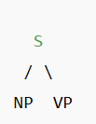
Parse Tree:

Complexity

Time: O(n³ · |G|)

Applications

Syntax analysis

Machine translation

Grammar checking

Statistical parsing (PCFGs)

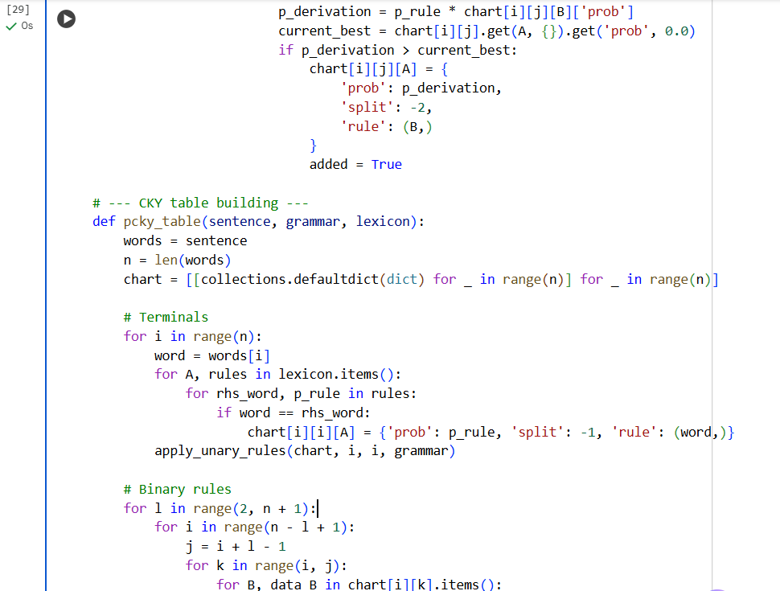
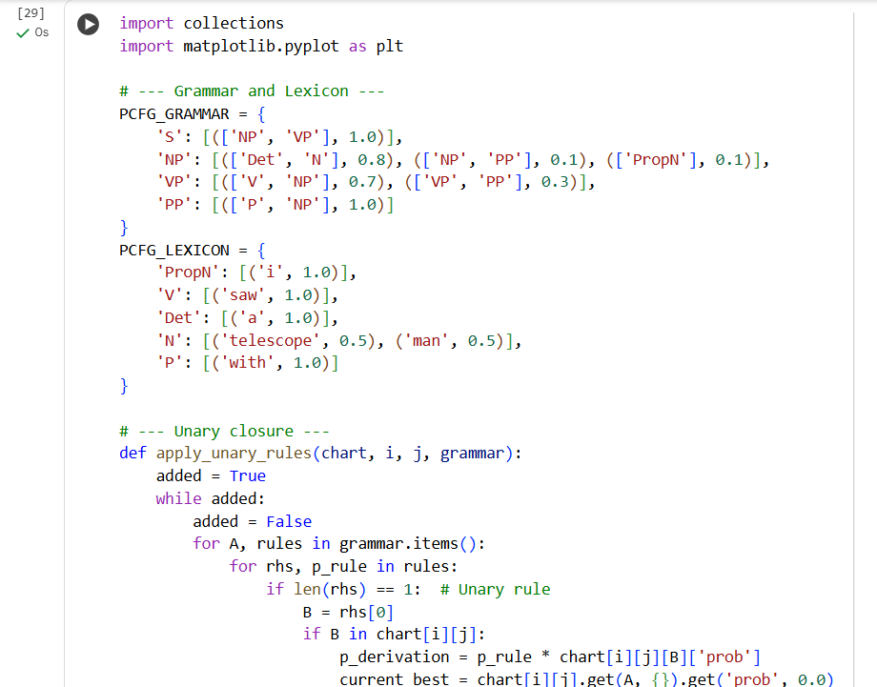
Code:
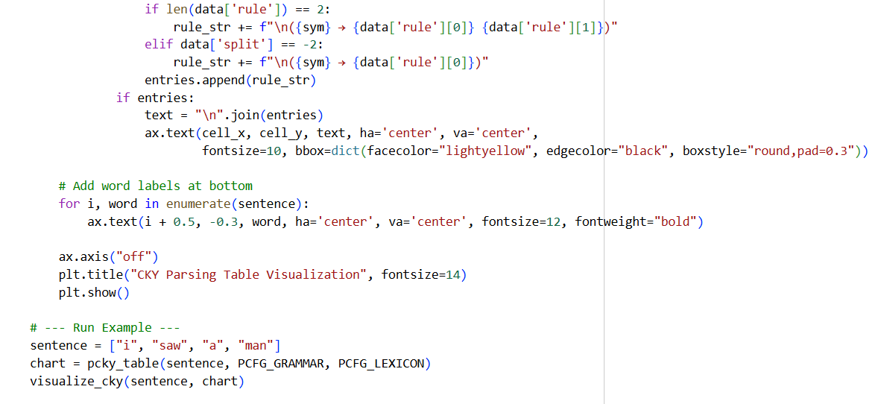
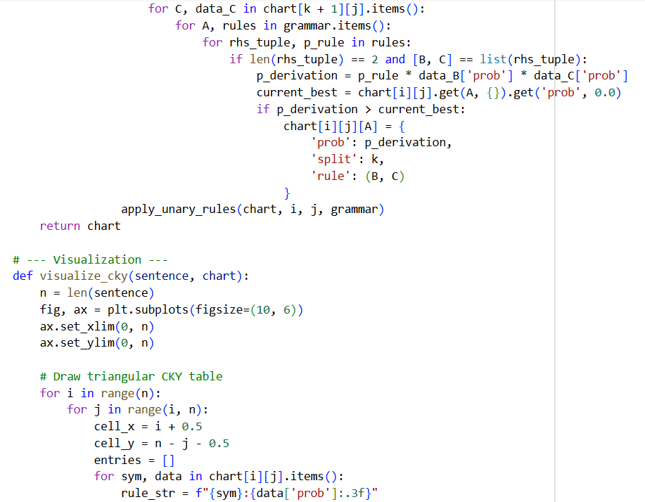

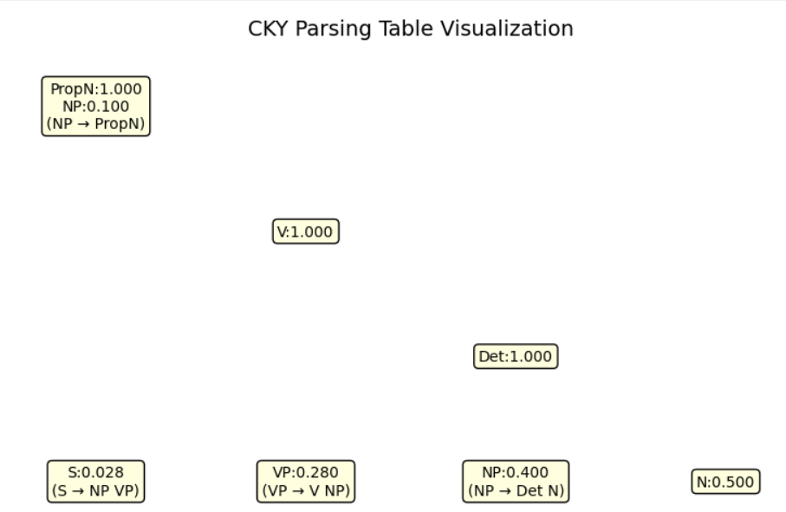
Output –

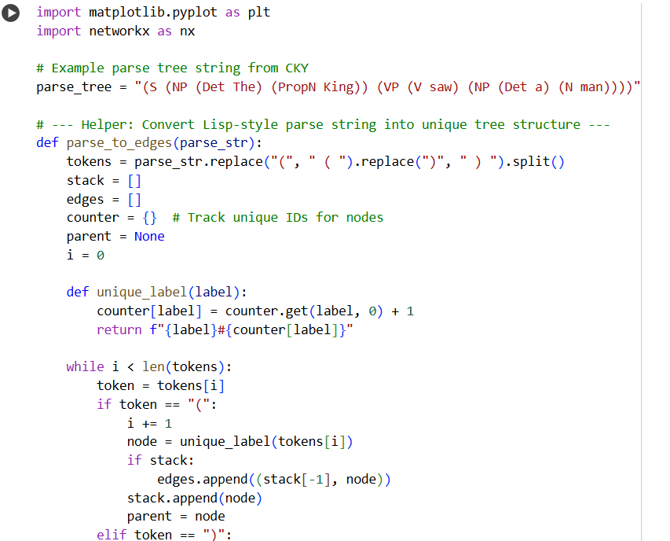
Code:

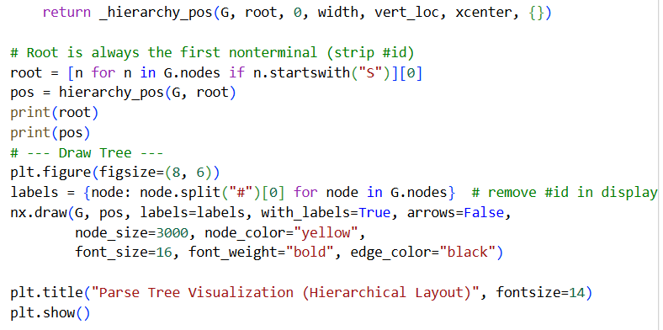
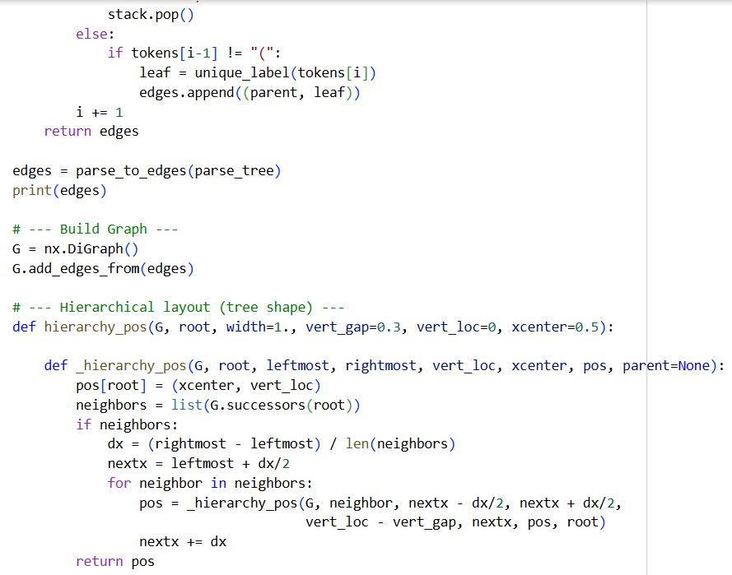

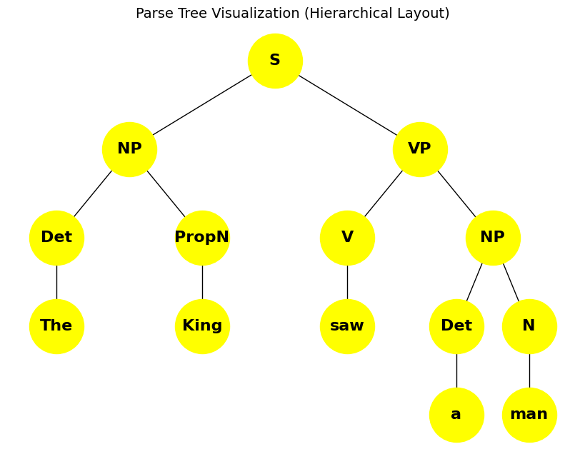
Output:

